REFLECTIONS OF SINGERS HILL ON THE OCCASION
OF ITS 165th ANNIVERSARY
by Sir Bernard Zissman

For the avoidance of any doubt, I was not present at the start of its history in 1856 but my association with the synagogue does goes back over half of its amazing journey.

These are personal reflections and to quote the words of our late and respected Her Majesty Queen Elizabeth ll speaking about other matters, “reflections may vary”, so my apologies if others have different memories and mine may be wrong.

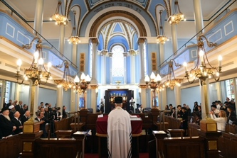
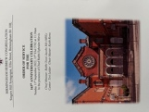
Let me start with the “now”. I am full of admiration for Rabbi Yossi and Rebbetzen Rachel Jacobs, their energy, their enthusiasm, their optimism and their love of Judaism and how it is as relevant in the 21st century as it was in the 19th century and beyond. I also want to applaud the synagogue executive, especially Gerald Bloom and John Leek, not only for their decision to bring Rabbi Jacobs to Birmingham but also for their close to two decades commitment to the preservation of Singers Hill, its magnificence and beauty; their dear parents and grandparents would have been very proud of their work – but more of this later. 165 years of history were truly celebrated on September 11th first with a memorable service and secondly with a wonderful dinner, and I congratulate and thank Amanda Georgevic and Laura Bushell and those in their team for their supreme effort of successful organisation.

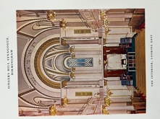
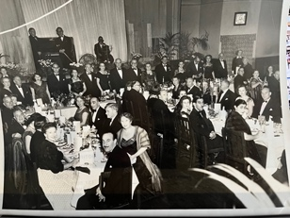
My first recollection of Singers Hill was probably in the early nineteen forties, having returned with the Hebrew School from a mining town in Leicestershire where we had been evacuated to protect us from the Nazi bombing heavily on Birmingham. I sat in the shul squashed between Grandfather Meyer and Father David until I was able to get a temporary seat in the aisle in a synagogue without a seat to spare. Seating capacity had risen to 1300, almost double the number in 1856 and had necessitated the adding of an extra row at the front of the ladies’ gallery adding 140 seats, and changes to the location of the bimah provided space for 80 more men, the result of the work of Jack Cotton who, together with Joseph Cohen, had been such benefactors of Singers Hill. One of the surprise additions was a microphone which remained in place for some years until wiser heads decided it was inconsistent with Jewish law.

The Rev Dr Abraham Cohen would give outstanding and widely quoted sermons, but hardly understandable to a seven year old. To be frank, I believe both he and I would have preferred for me and other young children to be elsewhere during the sermon! He got his way on Yom Kippur when a crowd of youngsters would slip out and walk around the Museum in Victoria Square. Rev Dr Cohen served Singers Hill for 36 years and was given a farewell dinner in 1953.

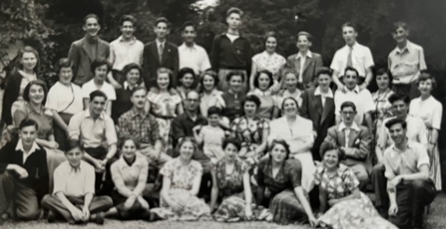
However the amazing chazanut of Chazan Lewi [who became close friends with my parents-in-law Pep and Ronnie Glass] would hold the entire congregation in awe as he sang out, accompanied by the choir under the leadership of Jack Goldman and which included my wife Cynthia, located in a balcony above the bimah. Raising the roof with his singing the final words of Neilah will always be in my memory. The spiritual team included during this period Rev S I Solomons and as if appearing from nowhere, an elderly Rev Dainow who only came from behind a screen as we sang Adon Olam. Later of course we welcomed Rev Dr Pearl and Rev Brookes both of whom had an impact on our lives and later still Rev Gold. Prior to Rabbi Dr Tann occupying the pulpit, ministers in Singers Hill always wore the clerical “dog collar” which it was claimed made easier access to hospitals and prisons. Picture shows Summer School in Lenk led by Rev Chaim and Mrs Pearl 1951.

Singers Hill in the forties was heavily influenced by the Second World War. Services continued in the adjoining Communal Hall but with many congregants either serving in HM Forces or on the Home Front, life was interrupted and in this period the ladies were brought downstairs to the centre block until returning, with some opposition from some ladies, to the gallery in 1984. When the ladies returned again to the ground level, this time behind a controversial mechitza, opposition was raised again, this time from some men.

During the war years, authority from the Chief Rabbi was given for the carrying of gas masks during the sabbath as required by the law of the land. At this time, the railings fronting the synagogue were requisitioned for the government war effort and were not replaced for many years. A home for refugees was generously provided by Julius Leek, grandfather of Executive member John Leek. One of the approaches to the Singers Hill was via Ellis Street, now the location of the car park, but then a street of Victorian terraced homes, many occupied by Jewish families in bygone years until they moved to Mosely and Edgbaston. On May 13th 1945 Singers Hill hosted a community Service of Thanksgiving to mark the end of WWII. Children’s services on the High Festivals were crowded in the Communal Hall as we were “encouraged and controlled” by Mark Harris singing loudly and at the time the Headmaster of the Hebrew School. His son, George became the consort of Councillor Miriam Harris who on becoming Mayor of Solihull in 1983, held a special service in Singers Hill.

In December 1947 I celebrated my barmitzvah with parasha Vayechi alongside Brian Franklin and Stuart Barnett, all three of us looking up in awe at that great orator Rev Dr Cohen who addressed us. There has often been a difficulty in the succession of synagogue lay leadership and in 1943 when E P Hollander and I L Lyons gave up office and Ivan Shortt began an illustrious period, it was agreed that “it should be clearly recognised that an essential qualification for the office of President was regular attendance at synagogue on sabbaths and festivals”.

At this time there was a clear division between the established Anglo Jewish membership at Singers Hill, keen to retain a firm Jewish “traditional” identity and the membership of Central Synagogue [of which Cynthia’s grandfather was a founding member] led by Rabbi Reuben Rabinowitz who wished to practice a more orthodox Judaism. This however did not prevent many parents sending their children, myself included, to the Talmud Torah three times a week as opposed to the more relaxed cheder at Singers Hill, only on a Sunday.

On Shabbat it was the custom for the synagogue ministers and wardens, with a band of orthodox members who had been present for shacharit, to process out, returning after, it was believed, drinking a crafty cup of coffee, and resume the service for the Reading of the Law with a larger congregation. One often recalls strange events and one was the regular entrance to the synagogue of Louis Bloom, the grandfather of Executive member Gerald Bloom who had established a successful business in the city and who always arrived dressed elegantly and correctly and suitably acknowledged, he arrived with his wife Eva who had founded the Eva Bloom Lodge devoted to charitable work in the Community. At that time and until 1996 when President Keith Drapkin introduced some informality, the President and Wardens wore morning coats and top hats, with dinner jackets at Kol Nidre.

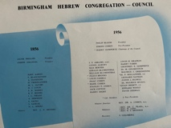
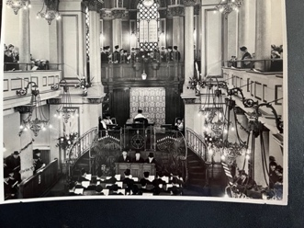
The 1950s was a significant decade for Singers Hill. In 1956 the synagogue celebrated its Centenary and this was marked by a special service attended by Chief Rabbi Dr Israel Brodie. The Council had elected Philip Bloom as Centenary President, Joseph Cohen as Vice President and Treasurer with Harry Gompertz as Chairman, a most formidable and successful team. In this period, the first Midnight Selichot Service was introduced and the Bat Mitzvah service was resumed after some years gap, having been originally introduced by Rev Dr Cohen, and an entirely visionary idea well ahead of its time in the UK. One of the features of the Centenary year was the project to completely replace the windows of Singers Hill with a magnificent collection of stained glass windows, a project excellently led by Joseph Cohen and when finished, not only recorded the history of the Jewish people but were dedicated by generous members whose names will forever be linked to the history of the synagogue.

The Council of that day consisted of many names who dedicated themselves to the future of Singers Hill, continued in some cases by sons following in the footsteps of fathers. 1958 was the year that Cynthia Glass married Bernard Zissman, bringing together two longstanding Birmingham families.

Over the history of our community there have been many crises and disagreements, the refusal of the members of Singers Hill Council to attend the launch service of the Liberal Synagogue in 1936 and the breakaway, before my time, of those who did not see their religious future with such an Anglicised congregation and forming a rival orthodox synagogue and Beth Hamidrash in Wrottersely Street, eventually moving to Bristol Street and now Pershore Road. A heavy increase in seat rentals prompted the mass resignation of the Council, saved by the diplomatic intervention of S P Abrams, father of Leon Abrams, both eminent and dedicated supporters of Jewish Education in the community.

I recall the vision of our forefathers in Singers Hill who felt an obligation and had the means to provide for all the Jewish community in Birmingham and did so by the development of cemeteries, the Hebrew School [now the King David] in St Lukes Road, which I attended at the time of its centenary in 1943, and support for the mikvah even though rarely used by Singers Hill members. It was the leadership of Singers Hill who established the Representative Council to try and foster goodwill and a relationship across the community and which to this day, led by an energetic Ruth Jacobs, still does just that.

Singers Hill has always had a close relationship to Israel, bringing the community together in happy times as well as sad and tragic times and records show that in proportion to its size, more of our community made aliyah following the establishment of the State of Israel. Services for the welfare of Israel were held at the time of the State’s establishment in 1948, and when the small country faced threats from neighbours in the Six Day War in 1967 and one clearly in my mind as Yom Kippur was terminating in 1973 and the voice of the BBC’s Michael Elkin reported on the attack on Israel from all its neighbours, those of us involved with JIA met immediately at the conclusion of Yom Kippur to decide how best to help.

Of course the wheels of Singers Hill continued rolling and was only possible by the loyal service of its professional staff. My memories recall Harry Goldman a wonderful shammas, resplendent always in silk top hat and gown, who not only organised the aliyot and I suspect organised the ministers too, but also walked around the town collecting seat rentals from many members who had set up businesses in Birmingham. A new era began with Harold Morris and Bernard Gingold, who doubled up as Secretary following many years of service by Ronny Singer, and more latterly Alan Wenble.

Singers Hill services have always been special and contrasted with most UK congregations due to the ever presence of a choir which has been ably conducted in modern times by Henry Black, Mark Woolf and to this day, by Keith Rowe.

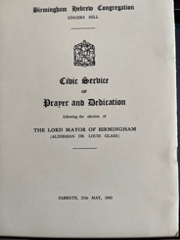
Singers Hill has always maintained a close relationship with the City authorities; the relationship with the City pre-dates the opening of Singers Hill but was secured forever when the architect of the synagogue, Yeoville Thomason, used this achievement to win the contract to design the Council House in Victoria Square. In the early days an Annual Civic Service took place on a Sunday so as not to disturb the shabbat services. This moved to the shabbat when the Lord Mayor together with a whole range of spiritual and civic leaders across the City accepted the Executive’s invitation. I will mention two of these occasions. The first in May 1963 when Alderman Dr Louis Glass and the Lady Mayoress Mrs Joy Glass were welcomed by President Philip Bloom into Singers Hill and blessed by Chief Minister Rev Sidney Gold.
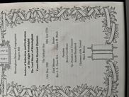
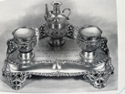
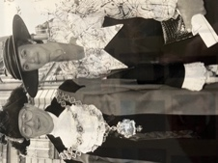
The second occasion, which was particularly significant to my wife and myself, was in May 1990 when, at the special request of Cynthia, the Service of Induction and Dedication of the new Lord Mayor Councillor Bernard Zissman was held in Singers Hill instead of St Martins in the Bull Ring. The mace of the City followed by a be-wigged Chief Executive, Aldermen and Councillors processed into a crowded synagogue. The service led by Chief Minister Rev Leonard Tann and Reader Henry Black was memorable, made even more so by the arrival of Rabbi Marcus Singer who had walked from Central Synagogue to offer a blessing to the new Civic couple. An everyday reminder during our Lord Mayoralty of the link with Singers Hill was the silver ink stand presented on the occasion of the centenary which still stands on the desk of the Lord Mayor and which Cynthia ensured was cleaned with dedicated regularity.

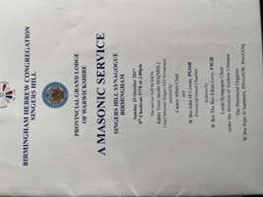
Singers Hill has hosted three services for the Warwickshire Freemasons, the first in 1984 when all three of the synagogue wardens were themselves masons, Harry Gompertz, Gerald Blumenthal and David Zissman, the most recent in 2017 in the presence of a full and respectful congregation. Members of the Birmingham Hebrew Congregation had been active in the founding of lodges with predominantly Jewish members and The Rev Dr Cohen had been a Grand Lodge Officer and a founder of the Lodge of Loyalty, which together with the Lodge of Israel, now meet in the original synagogue in Severn Street.

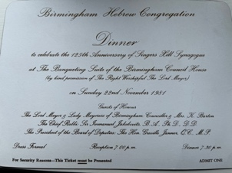
Singers Hill has never missed an opportunity to celebrate its history. Following the Centenary in 1956, the 125th Anniversary was marked in November 1981 with a service of Thanksgiving in the presence of Chief Rabbi Sir [later Lord] Immanuel Jakobovits. A Dinner held in the Banqueting Suite of the City’s Council House was an elegant and memorable occasion under the Presidency of Roland Diamond. I was accorded the honour of proposing the toast to the City of Birmingham in which I reminded the guests that “one of the earliest Presidents of Birmingham Hebrew Congregation, Jacob Phillips had been a Councillor, followed by Sir David Davis who served as Lord Mayor and was a synagogue council member. At its founding meeting in 1839, the City Council displayed an example of tolerance in allowing Councillor David Barnett who was an early President of the Congregation, to take the oath without committing to the Christian faith.”

It is interesting that of the four Jewish Lord Mayors, Cynthia is related to three, her uncle Dr Louis Glass, her cousin Harold Blumenthal and her husband Bernard Zissman!

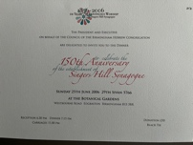
The 150th anniversary of Singers Hill was celebrated with similar style, a special service plus a Celebration Dinner at the Botanical Gardens on June 25th 2006. There was a unique occasion when the Shabbaton Choir together with Chief Rabbi Sir [later Lord] Jonathan Sacks attended the 150th Anniversary Midnight Selichot in Singers Hill. This was the result of my invitation to Chazan [later Rabbi] Lionel Rosenfield when we met in Australia at the wedding of Adam and Rachel Cohen and which he agreed to only if we guaranteed a full synagogue! Those who attended can attest to the wonderful spiritual experience and indeed with a packed synagogue from across the whole community.

Returning to the “now” and the future, there have been several attempts to achieve a merger of the two orthodox congregations, first by President Benny Goodman, then President Keith Drapkin and finally in my term of office. All failed; the last attempt in 2004, after many months of negotiation achieved a 90% vote in favour from Central members and 74.6% from Singers Hill, just 0.4% under the required 75%. Every Prime Minister would give his/her right arm for such a majority. At the time some harsh words were spoken, some unkind others not true. Any responsible leadership must consider all options, even those which may be unpopular, when faced with an insurmountable challenge. The Executive of the time of course considered how best to secure and protect for posterity our amazing Singers Hill Synagogue. In the end a merger seemed the best option with a location of services yet to be agreed – and yes, a tough decision but with the wisdom of hindsight and goodwill [not to underestimate the mutual respect and understanding between Central Synagogue President Leonard Jacobs and myself] it was possible that Birmingham orthodox Jewry would end up davening in Singers Hill. The mutual ambition of the leaders of that time was to unite the community rather than see division. We had all witnessed our youngsters going off to university and then making their homes in the larger centres of Jewish life. What we had not foreseen was the parents would then leave to join their children as they TG grew older and needed the support of family.

I was born into the Singers Hill community, my brit mila was within the community, I had my bar mitzvah and was married in Singers Hill and my great grandchildren, though living in the USA, will be named in Singers Hill. I served as did my father as synagogue President. I will always remember the pride of sitting in the wardens’ box, joined over time by Ivor Lewis, Arnold Shepherd, Richard Saunders, John Fineman and Roy Cornberg, when I reflected on those who had gone before me including Oscar Deutsch, E P Hollander, Ivan Shortt, Philip Bloom and my own father. Can there be a greater commitment and could I ever be guilty of seeking to bring to an end such a journey of outstanding history.

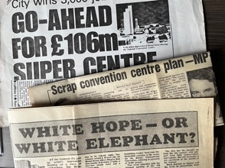
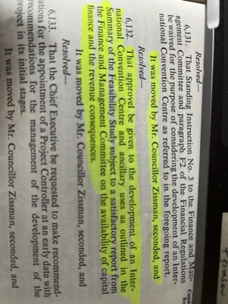
During my public career I have also faced many challenges, to some our response was right and to others not so right. Bulldozing the slums of the inner city in the 1960s was absolutely right despite disrupting local communities; putting our citizens in high rise blocks of flats was a huge mistake. In 1982 when I and a few around me saw that the future of our great city would no longer depend on the assembly lines at Longbridge and the out-of-date factories would soon disappear, I brought to the Council a revolutionary project, [see Council minute left] an International Convention Centre [ICC] and world beating Symphony Hall. The media and our opponents condemned it as foolish and a white elephant, but we remained convinced about the need to change the economic foundation of our city and all the communities who live in it. That start to regenerate Birmingham forty years ago led to the city hosting the G7 Conference of World Leaders, the snatching away of the political party conferences from the dreary hotels in seaside resorts, the 1998 Eurovision Contest and more recently the Commonwealth Games. Let history be the judge of our vision.

Let me close by wishing continued yasher koach– strength to the Rabbi and Rebbetzen and to those who continue to serve Singers Hill and its members. The challenges of two and three decades regarding shrinking provincial communities ago remain to this day but with the added issue of succession of lay leadership and who will pick up the mantle for the future ? Of course we should never ever forget the past and the legacy left by our parents and grandparents but the responsibility remains to look to the future, to the next twenty or fifty years, that requires exceptional vision and leadership.

